Interview: Gary Wise Part 1
Toby Wachter
Gary Wise is the kind of player who is considered either a successful competitor and a great ambassador for the game, or a loud, obnoxious creep. It all depends on who you talk to. Often controversial, constantly outspoken, and never dull, Wise has been a Pro Tour mainstay for years, and has become recognized as one of the top Limited players in the world. Through his weekly Sideboard column Wise Words and his card-by-card Limited analysis, Wise has also become one of the better known Magic writers within the community.
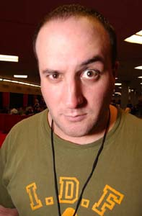
Recent events, such as becoming a target for insults from some players, and coming close to falling off the Pro Tour "gravy train" have made Wise a topic of discussion within Pro Tour circles. What does he think about comments made against him, and does he feel any added pressure to stay on the train because of his reputation? How has moving to England affected his life, both personally and professionally? I met up with Gary at Pro Tour-San Diego between rounds to discuss some of these topics. Keep in mind that this interview was conducted in the middle of Day 1, when Wise was still unsure how he would finish, and did not know whether or not he would be on the gravy train at the end of the day.
Wachter: How did you first find out about Magic?
Wise: I was attending the University of Windsor during Fallen Empires, and I had to go home for March break. When I did, a friend of mine told me about this game that was like Dungeons and Dragons without the roleplaying. It sounded absolutely awful to me, because roleplaying is what I liked about D&amp;D. He made me play, and he smashed me. I decided I hated it, and that I would never play again. That week I bought my first cards, and I had them stolen. I took that as a bad sign, and figured "That's it. I'm never playing Magic again." I went back to school and saw this guy playing, and got curious again and asked him if he would show me some more stuff. A few months later I came back to Toronto, Chaos Orb in tow, and played against the guy who taught me, and taught him why he shouldn't pile all eighteen of his lands into one little stack. At that point, I was hooked.
Wachter: What intrigued you about the game?
Wise: Well like I said, nothing really intrigued me at first. I've always been a game player, and eventually I'm going to want to try just about any game. Magic seemed like another way to challenge myself, because there were interesting aspects to playing the game, and to building decks for the game. I've always described Magic as a game of chess where you get to bring your own pieces. The fact that I could trade up to more powerful pieces than everyone else was really enticing. I had the Power Nine within six months, and was just crushing people with superior cards.
Wachter: Well since then, Constructed hasn't really been your thing. What was the difference between how you felt then, and where you are now?
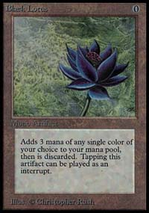
Wise: Well, I was a Type 1 player, and at the Mirage Prerelease in Toronto I loaned my deck to a friend of mine because he wanted to make a copy of it. So he had my deck, and his copy of the deck in a box. Mine was all Alpha, and his was all Beta, and the box was stolen. Nine months later, I caught the thief and justice was done. But by then, having lost my Type 1 deck, and not really understanding what Type 2 was, I started drafting. I got so into drafting that when I got the cards back, it didn't interest me anymore because all of a sudden there was this new way to outplay people and out-think people that didn't involve just having better cards. I was able to beat them in a more pure fashion. That really is a lot more satisfying. So, I sold off all my Type 1 stuff, except for my Black Lotus, which I still have. It's a special Lotus.
Wachter: Was there a point where you decided this wasn't just a casual thing anymore, and you were going to get serious about playing in tournaments and making money?

I just can't help but think, "What's the best way to try to win this game?"
Wise: You have to understand that I come from a very game-oriented background. My father ran the most successful Scrabble club in the history of that game. It's been around for about twenty-five years in Toronto now. I grew up with games all around me, and competition was just a way of life in my family. My Dad wasn't obsessed about competition, he was always a good sportsman. So I've always played games, and when I play games, I play them to win. Sometimes that's a fault. When I'm playing drinking games with the Ronaldsons, they don't want me to concentrate on winning, they just want me to be goofy. I just can't help but think, "What's the best way to try to win this game?" So, being a competitive player as opposed to a casual player came very naturally. As I got better, it became more apparent that it was what I should be doing, but I think even if I was absolutely awful, which some of my peers might say I am, I still would have gone to tournaments and done my best.
Wachter: You have a reputation for being an expert at Limited Magic. What do you think the key is to Limited play?
Wise: The key to Limited play is probably the ability to think on your feet. You can do all the planning you want, but... Constructed is very, I don't want to say simple, because simple isn't the right word for it, but it's very formulaic. You come up with the best deck, you play that deck well, you win. In Limited, you can do all the planning you want, but if the guy in front of you just drafts this style you're not accustomed to, then everything changes. You have to be able to adjust to that as fast as humanly possible.
Wachter: What's the key to playing sealed deck?
Wise: Keep your mana good. Mana problems happen a lot in sealed deck because everyone's three colors, and you don't have a lot of mana fixers. If you can keep your mana good, the likelihood is that you're going to get mana screwed far less than your opponent. There have been times when I've been very happy to run Stone Rain in a sealed deck because of that. Mana screw is a part of Magic, and sealed deck is the format that exploits it the most, so just try to keep your mana better than everyone else's.
Wachter: What's the key to drafting?
Wise: Are you going to ask me the key to life after this?
Wachter: (laughs) Sure, I can put that in there if you want.
Wise: The key to... the key to life is... (laughs)... the key to drafting: pick your colors, stay focused, don't make the guys next to you angry.
Wachter: Are there any major mistakes you often see players making in Limited?
Wise: One thing that distinguishes the top pros from the next tier of players is the fact that the pros are able to identify deck synergies, which will affect their draft picks. For example, in a draft I just did, there was a situation where I took a low casting cost creature over a Dirty Wererat because of the fact that my deck already had a lot of four casting cost cards, and I needed to even out my mana curve a little bit. You have to understand that you're not drafting the best cards. You're drafting the best deck.
Wachter: Everyone knows you're mostly known for your "Limited Skills", I really hate to use that line because it's so played out...

I was a horrible, horrible English student all the way through high school. I couldn't write for a lick.
Wise: That's fine. Actually, that was originally said by Christa Stenger, who is Talvi's sister and Kurt Burgner's wife now. She wrote that, not even meaning it the way it sounds. She said it because I was basically known as a Limited player. So, it was pointed out to me by Eric Covener one day that it could be interpreted in a different way, and I actually thought it was really funny. I've always quoted it. I think it's great.
Wachter: So, do you think there's any reason why your Constructed game isn't as well known? Do you think that you're weak in that format, or people just don't know you're good? Do you consider it a part of your game that could be improved?
Wise: Well, it comes down to two things. First of all, dedication. I'm a much more dedicated Limited tester... or at least until recently. When I moved to England, and moved in with the Ronaldsons, I started playing a lot of Constructed with Ben. A lot more then I've played in a long time. But in the past, it's always been the case that I've done a lot of Limited play and very little Constructed play. I'd sort of just grab a deck when I got to the Pro Tour, and hoped for the best. The other thing is, because of the fact that I'm more confident at Limited, I'm more willing to speak about it in public forums, like Wise Words. As a result, people know what my opinions are and whether I'm confident with certain things in Limited, while with Constructed, I'm pretty much silent.
Wachter: Does that help? Do people say to themselves "Okay, so I know Gary drafts this, because I know that from his column"?
Wise: Well, I think it's a valid point, but I've never really believed in the philosophy of announcing your deck preferences on the internet in the hopes that everyone will respect them. Not everyone reads my column. Like there are definitely players at this Pro Tour who have no idea who I am. There are guys who went to a qualifier and won it, and thought, "Hey, it might be fun to go to the United States and play some Magic". For me to expect them to know I want to draft blue-white or blue-green or what have you, it's just unrealistic. Because, if I go in with that expectation, what's going to happen is I'm going to get screwed by someone, and I'm not going to know how to adjust. That's bad. Like I said, draft is about being able to adjust quickly, and to just pick one strategy and stick to it wouldn't work.
Wachter: At what point did you decide to "go pro"?
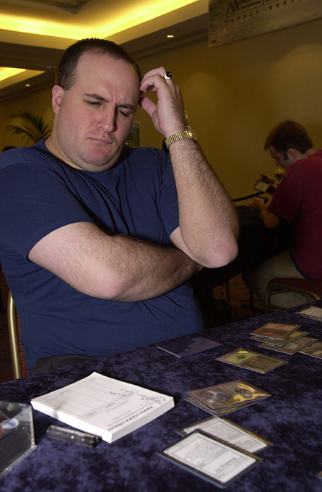
Wise: Going pro was a very natural metamorphosis. I was at University, and I was writing part time for Sideboard, and when I graduated I just kept on writing for a while. I was lazy about looking for a job and so on, and I wanted to see where Magic would go. I was in the first Masters, so I wanted to see how I would do there. That was at Pro Tour-New York, which Potato Nation won. At that Pro Tour, I went to Skaff Ellias and said "I'm at the point now where I'm not doing quite as well as I'd like to if I wanted to be a professional player. Maybe it's time for me to become a writer who plays instead of a player who writes, or for me to find another job." Then, Potato Nation won the Pro Tour (laughs). All of a sudden I had $20,000 in my pocket, and a year's worth of Masters qualification, so the decision to go pro at least for that next year was very easy. Now I'm off the Masters and I'm doing a little more writing. I announced in Wise Words last week that one of my New Year's resolutions was to write a book. So, I guess I'll stay put for a while, but really I'd consider myself more of a Magic writer than anything else.
Wachter: Do you think that going pro gives you an advantage over other players who have school, or work, or other responsibilities?
Wise: Well, obviously the more time you dedicate to the game, the better you're going to do, or at least the more prepared you'll be. I think that natural talent is always going to be first and foremost amongst the important qualities required to be successful in Magic. For example, John Ormerod, my teammate, just went on a three week trip with his father. He didn't get to practice Odyssey, and if you were to ask if it helps me as compared to John that I've been practicing for the past few weeks while he hasn't? Absolutely. Environment knowledge, card knowledge, card interaction knowledge...those are all important. John's a very talented player, and this in no way suggests that I have anything but the highest respect for him, but I know that I personally feel a lot more comfortable with a format when I practice it.
Wachter: Was it scary to make the decision to turn pro? It's one thing to be a Budde or a Finkel and know you're going to have consistent money finishes, but when you're not like that and you're not so sure the next check is going to come in, it's more of a risk.
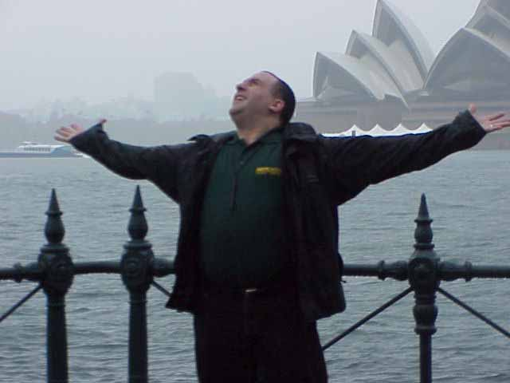
Wise: I think that it comes down to the kind of person you are. I don't have a lot of responsibilities with regards to family and so on. I'm not married and I don't have any kids, and I'm not worried about getting rich. So, that allows me to be a little bit freer with how I spend my life. If you're the kind of person who wants to be making $50,000 a year, getting dental and medical (coverage) and so on, and just making sure you're set up for when you're 40, then Magic right now is not what you want to be doing. If you're the kind of person who is willing to live life one day at a time and just have a little fun, and for whom money isn't that important as long as you survive, then it's a great way to make a living. In the calendar year from December 2000 to December 2001, I went to six continents. I played games, and I made a good living. I can't ask for much more than that. It was a good year for me, and if it was a bad year, it obviously wouldn't have been quite as much fun because I wouldn't have been winning as much. But still I have a lot of friends I get to see because of these tournaments, and I get to see a lot of the world. I think I've traveled more than 99.9% of the world's population and I'm only 28, so fear really wasn't a factor. I just do what makes me feel good, and playing Magic professionally does that.
Wachter: Does it scare you that ten years, twenty years down the line that this may be detrimental?
Wise: If Magic were to eventually fold, and I don't see that happening in the foreseeable future since the Pro Tour just keeps getting stronger...
Wachter: Well for example, let's say you're 35, and you're not doing as well with Magic and you want to settle down and get a job. Do you think that because you don't have as much experience with working as someone else your age that it might be harder to get a job?
Wise: It's funny. I've got a degree, and I'm trained in any way I need to be to be a film critic, and there are a couple of other jobs that I think I'm definitely qualified for. But if nothing else, Magic has given me a really impressive resume. I've got a list of writing credits that goes longer than any resume should go. I think that an employer would be able to gather that I'm a fairly intelligent person by virtue of the fact that I've been playing an intellectual game on a professional level. I'm about to do a book, and that's going to look amazing on my resume. And yes, you know what? Eventually quitting Magic will mean starting over, and that's never going to be easy. But at the same time again, it comes down to your willingness to. I don't mind starting over. I don't mind the fact that I may eventually have to do so. At the same time, right now I really don't want to. I'm very happy doing what I'm doing. I have a great job, and I don't think I'd trade it for anything.
Wachter: Were you writing before you got into Magic, or is that something you developed from the game?
Wise: It's actually really funny... I was a horrible, horrible English student all the way through high school. I couldn't write for a lick. There was this website called The Magic Dojo, where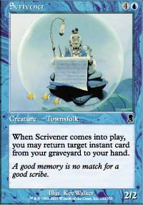 everyone was writing these tournament reports and it was just so much fun to read them. So I decided one day after winning a PTQ to write one of my own about Mike Donais' Ertog deck. Mike and I were teammates way back in the day because we went to University together. About a week after I wrote that report, Alexander Blumke, former World Champion, emailed me thanking me for the deck. He took it, and won a PTQ with it. That was really inspiring, so I just started writing more. If you look back in the Dojo archives, there's some horrible stuff under my name. I never edited anything, and I'd even start off "I'm not going to edit this because I'm lazy" and now I'm like "What was I thinking? Just get a spellchecker!" Eventually, I started getting more and more positive feedback, and I just guess practice... I still don't know that I'm that good a writer. I get a lot of compliments about my Magic writing, but I still feel that I can get a lot better. I don't have any professional training or anything like that, it's just very natural to me. I always took the approach of writing as if I was sitting across from someone at a coffee house. I guess that works for a lot of people because it doesn't get too brainy in a field where you really don't want to get too brainy. I'd like to think that I can get a lot better, and hopefully the future will show that. I'm really glad that Magic showed me that I was able to do this, and that's one thing for which I will always be grateful.
Wachter: Do you have any advice for aspiring writers?
Wise: (laughs) I don't really want to go into individual writers, because there's some out there who aren't very good unfortunately...
Wachter: Well, what are some of the major things you see writers doing that you think shouldn't be done?
Wise: (voice gets a bit louder and more sarcastic) I think that one thing that really shouldn't be done is when a writer refers to someone as "Becky" over and over again. It's unprofessional, it's always tied up in some kind of weak tangent, and frankly you have to be really, really bald to do it. Aside from that... (laughs)
Wachter: Okay, aside from people who are named Rizzo...
Wise: Who? (laughs)
Wachter: I mean some kid that wants to start writing, and wants to become a Magic name by writing. What advice would you give to someone like that?
Wise: Okay, there are two things that I think are really important. First of all, you have to be careful not to try too hard. Don't try to write, try to speak. Write the way that you feel, don't worry about extensive wording and the like, just worry about getting your point across in as simple as fashion as possible. Second of all, and this is going to sound wrong because I talk about myself a lot in my column, but you don't want to talk about yourself too much in regards to topic areas that don't really concern you. There are a lot of writers who do that, and I find it really ruins the articles a lot of the time. I think it really spoils what could otherwise be a really good topic matter. Obviously where it's appropriate, you can talk about yourself. When you're talking about team Limited, and you mention Potato Nation, obviously you mention your involvement with that tournament. But if it's me and I'm talking about Constructed expertise, I'm not going to say "Oh, by the way, I did this" because quite frankly, I'm not the person who should really be spoken about. If you can keep the ego in check, then you'll do a lot better.
Wachter: Some people criticize your writing. I've heard people say, "Gary Wise is arrogant, and he's obnoxious." Do you feel this is justified in any way, and would you consider changing to make these people happy?
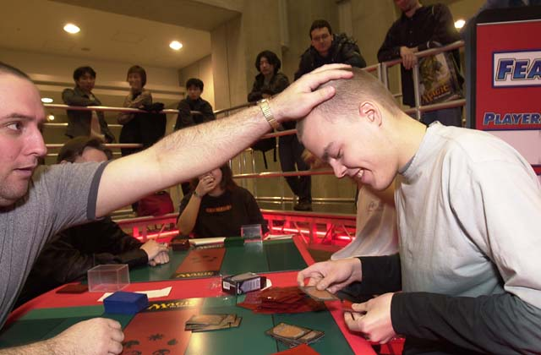
Wise rubs Tommi Hovi's head, presumably for luck.
Wise: They're absolutely correct, and there's no way I would ever change. I think one thing that makes me a good writer is the fact that I'm very willing to express my opinions. My opinions. They're not the opinions of Sideboard, or anyone else. They are mine. That's one of the reasons Sideboard likes me, because of the fact that I'm outspoken, and I'm very willing to get my point across. For those people who want nice, generic articles, I don't see the point of having a human being write those articles. I think it's the writer that gives the article flavor, and it's my personality coming through. Am I obnoxious? Absolutely. I've made some people mad. I have a very strong personality, and I understand that I inspire some people to love me, and some to hate me, and that's never going to change. I think that the fact that the people who hate me still read the column is what really says a lot about what I'm doing.
Wachter: Being a writer and a Magic celebrity often means giving players advice. Does that ever become overwhelming?
Wise: Yeah, it does. I used to have my email address on Wise Words, and I was getting on average about 250 emails a week. Some of them were emails from people who were asking for deck advice and the like, and they were asking the wrong guy. It was really time consuming, and quite frankly I didn't have the time or the will to sort through all of them. So I stopped using that email address, and I announced on Wise Words that I'm not going to post my email address anymore. I have had people tell me that they think it is my obligation to answer all that email. When I answer an email, I don't want to do one sentence and send it back, I want to answer it properly. That means spending a good ten to fifteen minutes on it, and when you're doing 250 a week, 250 emails times ten to fifteen minutes is a lot of hours.
As much as I do like to help the community out, there are limits to how helpful I can be until I get frustrated by the whole thing, and I have to consider my own best interests when I'm making decisions about that kind of stuff. I do answer emails occasionally now, but I really try to answer all the questions in Wise Words before they're asked. Unfortunately I think that sometimes the reader doesn't listen much, because they still send me a Constructed deck when I say in Wise Words "I am not the guy to do that with, because I am not as knowledgeable as a Brian Kibler or a Zvi Mowshowitz. They are better deckbuilders than me, and therefore they can give better advice." Another important aspect of being a good writer is knowing your weaknesses and not trying to overcome them in a way that makes you look awkward. I'm not as good at Constructed as I am at Limited, so for me to answers those kinds of questions would be unprofessional. I think I owe it to myself not to be.
Tomorrow: Gary goes into how he really feels about Peter Szigeti, Chris Benafel, Ryan Fuller and Jay Elarar, and talks about what it's like to live in England with the Ronaldsons

Discuss this article on the message boards.

